AN EMPLOYEE REQUESTS INSTALLATION OF LICENSED SOFTWARE
THROUGH THE SERVICE CATALOG
Complete Project Documentation
ServiceNow – Service Portal, Service Catalog, Flow Designer, Approvals, Catalog Tasks,Notifications and Update Sets
Project | An Employee Requests Installation of Licensed Software through the Service Catalog
Platform | ServiceNow
Primary Interface | Service Portal
Workflow | Catalog Request → REQ/RITM → Approval → Catalog Task → Fulfillment → Status Tracking → Notification


The project focuses on developing an automated Licensed Software Installation Request Management system using ServiceNow. The solution provides employees with a simple and structured way to request software installation through the Service Catalog.
The main purpose is to capture software requirements accurately, obtain the required approval, create a fulfillment task for the software support team, and provide request status tracking throughout the process.
The system uses Service Catalog, Catalog Item, Catalog Variables, Flow Designer, Approval Requests, Catalog Tasks, and Update Sets to manage and transfer the software request configuration.
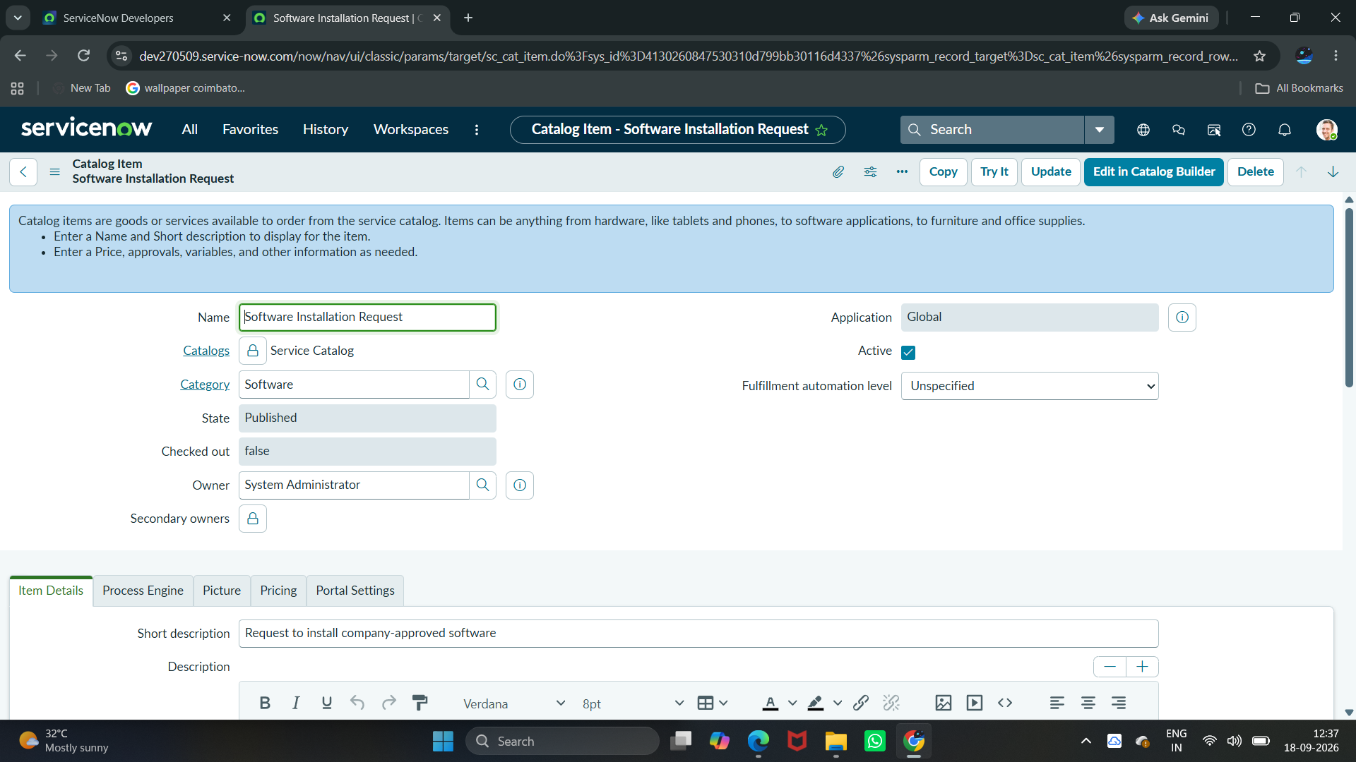
Figure 1: Software Installation Request – Catalog Item Configuration

Project Workflow
The implemented process follows this sequence:
- Employee opens the Software Installation Request catalog item through the Service Portal.
- Employee enters Software Name, Version Required, License Justification, and Urgency.
- Employee submits the request.
- ServiceNow creates the Request (REQ) and Requested Item (RITM) records.
- Flow Designer triggers the Software Request Workflow.
- The request is sent for approval.
- Once approved, the flow creates a Catalog Task (SCTASK).
- The task is assigned to the available Software support group.
- The task can be processed and its state updated.
- The request can be tracked through ServiceNow.
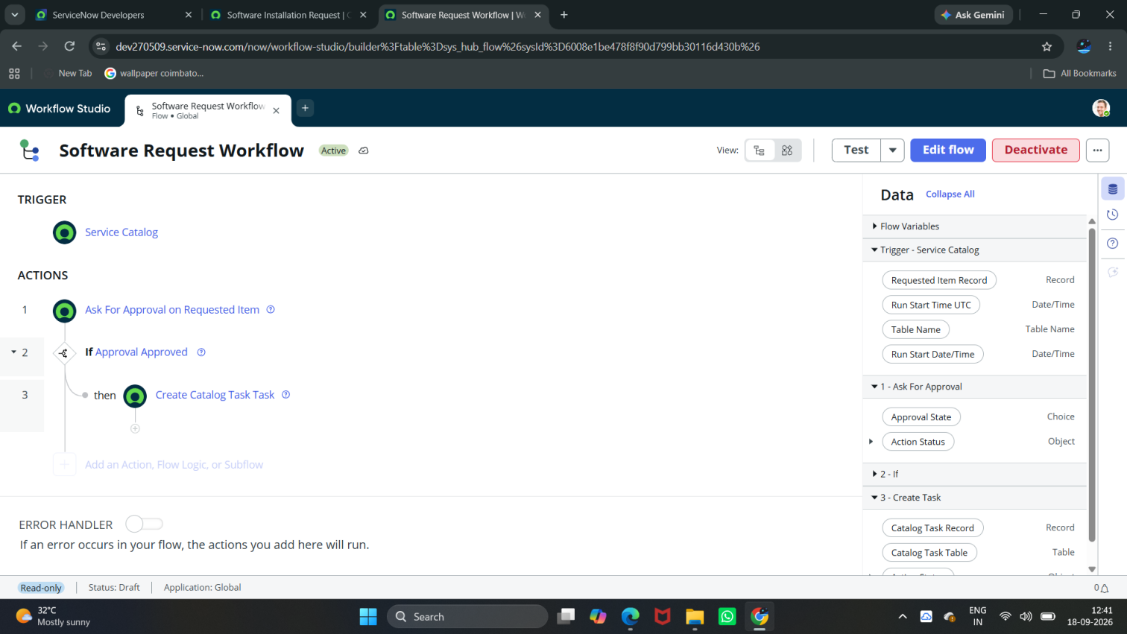
Figure 2: Software Request Workflow – Approval and Catalog Task Automation

Project Phases
The project was implemented through the following phases:
1. Requirement Analysis & Planning – Identifying the need for employees to request software through the Service Catalog and defining the required software, version, business justification, urgency, approval, and fulfillment requirements.

2. Service Catalog & Form Configuration-Creating the Software Installation Request catalog item and configuring the catalog variables required to capture software request information.

3. Workflow Automation & Approval-Using Flow Designer to automate approval processing and create a Catalog Task after approval.

4. Testing & Validation-Testing the catalog request, REQ/RITM generation, approval flow, Catalog Task creation, task state, and flow execution.

5. Deployment, Documentation & Final Presentation-Completing the Update Set, exporting and importing the configuration, resolving preview issues, committing the Update Set, validating the target instance, and documenting the completed project.

Final Outcome
The completed project provides a structured and automated process for employees to request software installation through the ServiceNow Service Catalog.
Employees submit a software request by providing the required software details, version information, business justification, and urgency. The request is processed through Flow Designer for approval, and once approved, a Catalog Task is automatically created for the Software support team.
The solution provides structured request tracking through REQ, RITM, and SCTASK records and uses Update Sets to transfer the completed configuration between ServiceNow instances.
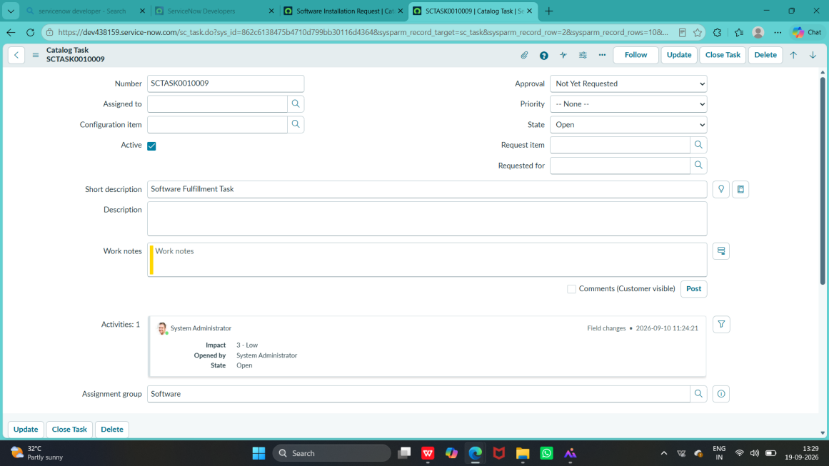
Figure 3: Software Fulfillment Catalog Task – SCTASK0010009
2. Phase 1 – Requirement Analysis & Planning
Step 1: Understand the Project Requirement
The main requirement is to provide employees with a centralized ServiceNow Service Catalog item through which they can request installation of licensed software.
The system should:
• Allow employees to submit a licensed software installation request.
· Capture Software Name, Version Required, License Justification, and Urgency.
· Route the request for approval.
· Automatically create a Catalog Task after approval.
· Allow the employee to track the request status.
· Maintain the request information through REQ, RITM, and Catalog Task records

Step 2: Identify Stakeholders
The major stakeholders involved in the process are:
• Employee / Requester – submits the software installation request.
• Approver – reviews and approves the request.
• Software Support Team – processes the generated Catalog Task.
• ServiceNow Administrator – configures the catalog item, flow, approvals, and deployment.

Step 3: Define ServiceNow Components
The following ServiceNow components are planned for the project:
• Service Catalog
• Software Installation Request Catalog Item
• Catalog Variables
• Flow Designer
• Approval
• Catalog Task (sc_task)
• Request (REQ)
• Requested Item (RITM)
• Update Sets
Step 4: Define the Request Process
The planned request process is:
Employee → Service Portal → Software Installation Request → Enter Details → Submit → REQ/RITM → Approval → Catalog Task → Fulfillment → Status Tracking
Step 5: Define Functional Requirements
The system should provide the following functionality:
• Employee can access the Service Catalog.
• Employee can open the Software Installation Request item.
• Employee can enter software name and required version.
• Employee can provide license justification and urgency.
• The request generates a REQ and RITM after submission.
• The request is routed for approval.
• A Catalog Task is created after approval.
• The Software support team can process the task and update its state.
• The requester can track the request status.
• The complete request remains traceable through REQ, RITM, and SCTASK records

Step 6: Project Planning
The overall project is planned in the following sequence:

Requirement Analysis & Planning → Service Catalog & Form Configuration → Workflow Automation & Approval → Testing & Validation → Deployment, Documentation & Final Presentation

3. Phase 2 – Service Catalog & Form Configuration
The second phase of the project focuses on creating and configuring the Software Installation Request in the ServiceNow Service Catalog. This phase converts the requirements identified in Phase 1 into an actual catalog item and request form.

2.1 Create the Service Catalog Item
A dedicated Service Catalog item was created for the software installation request.
Catalog Item: Software Installation Request
The catalog item acts as the entry point for employees to request software installation. It captures the software details, business justification, and urgency required to process the request.
The catalog item is connected to the subsequent request and workflow process so that the submitted information can be used for validation, approval, license checking, task creation, and fulfillment.
Figure 1: Software Installation Request – Catalog Item Configuration
2.2 Configure Catalog Variables
The request form was configured with variables to capture the information required by the Software Support Team.
The following variables were configured based on the implemented form:

Variable | Purpose
Software Name | Captures the software required for installation
Version Required | Captures the required software version
License Justification
  Captures the reason for requesting the software
Urgency | Captures the urgency level of the request

The variables ensure that the request contains sufficient information before it enters the automated approval and fulfillment process.
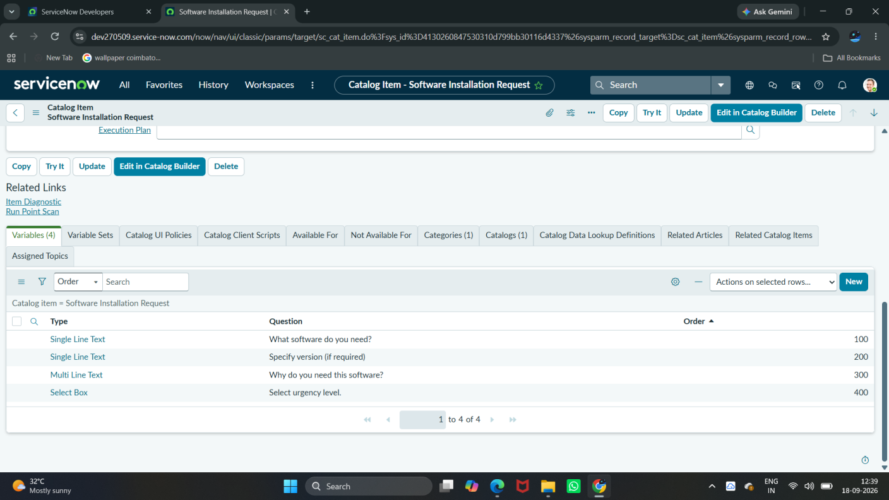

Figure 2: Software Installation Request – Configured Catalog Variables
2.3 Configure the Request Form
The Service Catalog form was designed to make the software request process simple and structured for employees.
The form captures the following major categories of information:
Software Information
· Software Name
· Version Required
Business Information
. License Justification
Priority Information
. Urgency

This information is later consumed by the workflow to determine the appropriate approval and fulfillment path.
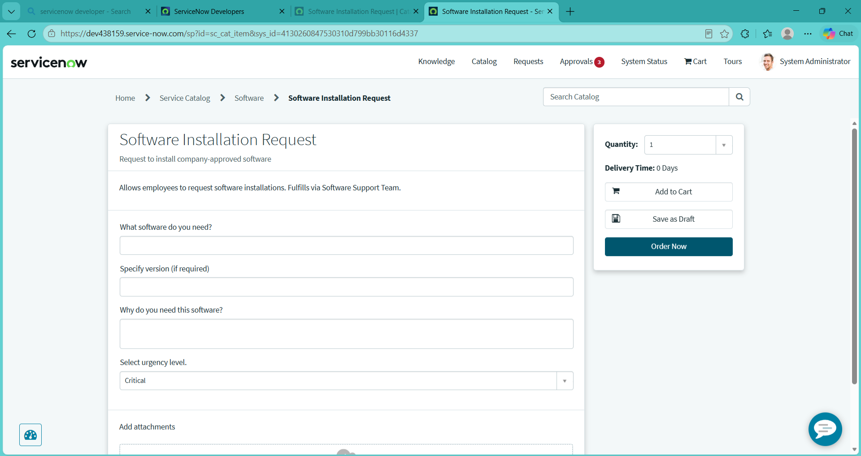
Figure 3: Software Installation Request – Service Portal Form

2.4 Form Validation and Mandatory Fields
Required fields were configured to ensure that employees cannot submit an incomplete software request.
The request form captures the key software information required for processing, including Software Name, Version Required, License Justification, and Urgency. These fields provide the information required for the approval and fulfillment process.
This validation improves data quality and prevents incomplete requests from entering the approval and fulfillment process.
2.5 Configure User-Friendly Form Behavior
The Service Catalog form provides a simple and structured request experience. The form allows the requester to enter software details, provide a business justification, and select the urgency level before submitting the request.
The Service Catalog form was configured to provide a structured and user-friendly experience.
The form configuration supports:
- Selection of urgency.
- Entry of business justification.
- Selection of the employee/requested-for information.
- Identification of the installation device.
- Required-date selection.
The collected information is carried forward to the Requested Item (RITM) and subsequently becomes available to the automated workflow.
2.6 Request and Requested Item Generation
When the employee submits the catalog form, ServiceNow generates the corresponding Request (REQ) and Requested Item (RITM) records.
The process follows:
Employee → Service Catalog Item → Catalog Variables → Submit → Request (REQ) → Requested Item (RITM)
The RITM stores the submitted catalog request information and becomes the Requested Item record used by the approval and fulfillment flow.
The workflow then uses this information for:

- Approval processing
- Catalog task creation
- Fulfillment
- Status updates
- Notifications
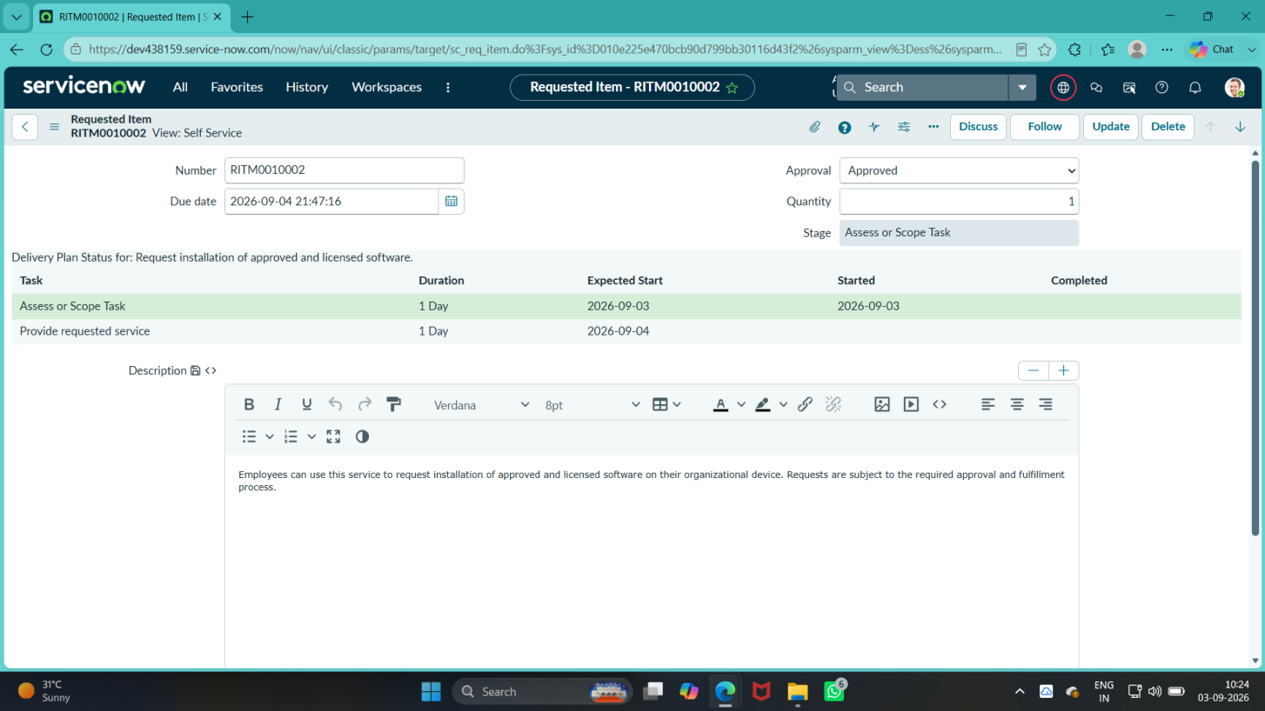
Figure 4: Generated Requested Item with Software Installation Request Details
2.7 Integration with the Workflow
The configured catalog item is connected to the Software Request Workflow through the Catalog Item process engine.
The implemented process is:
Catalog Item Requested → Ask For Approval → If Approval Approved → Create Catalog Task
After approval, the flow creates a Catalog Task for software fulfillment.
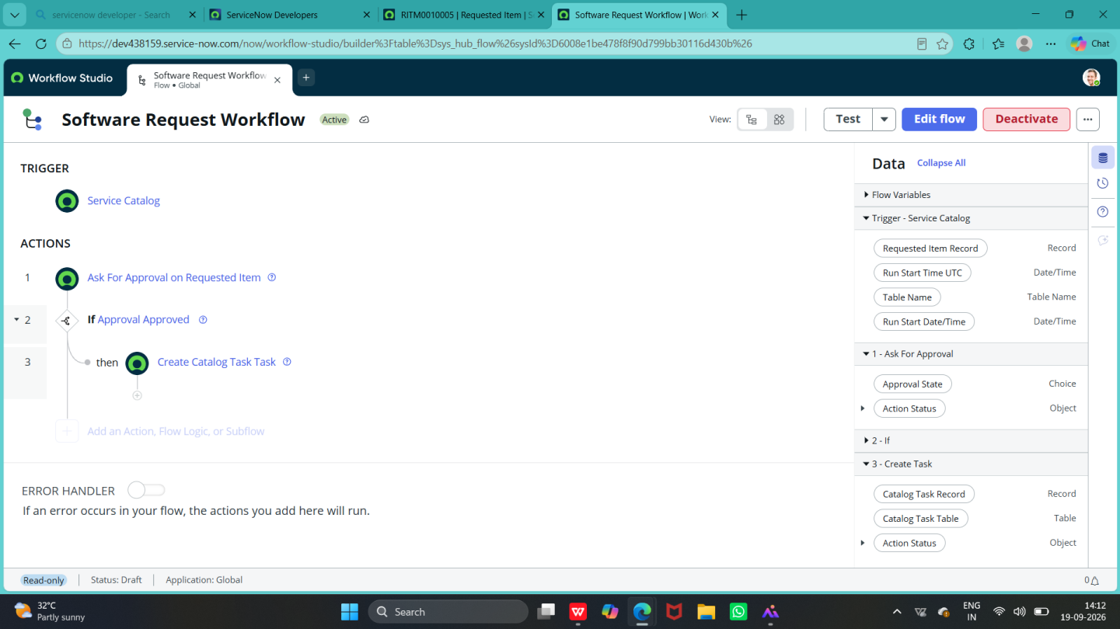
Figure 5: Software Request Workflow – Approval and Catalog Task Automation
2.8 Example of Configured Request
An example request was successfully created with values similar to:
• Software Name: Microsoft Office
• Version Required: Microsoft Office 2024
• License Justification: Required for academic and office-related work
• Urgency: Normal
This confirms that the Service Catalog form is successfully capturing the information required for downstream processing.
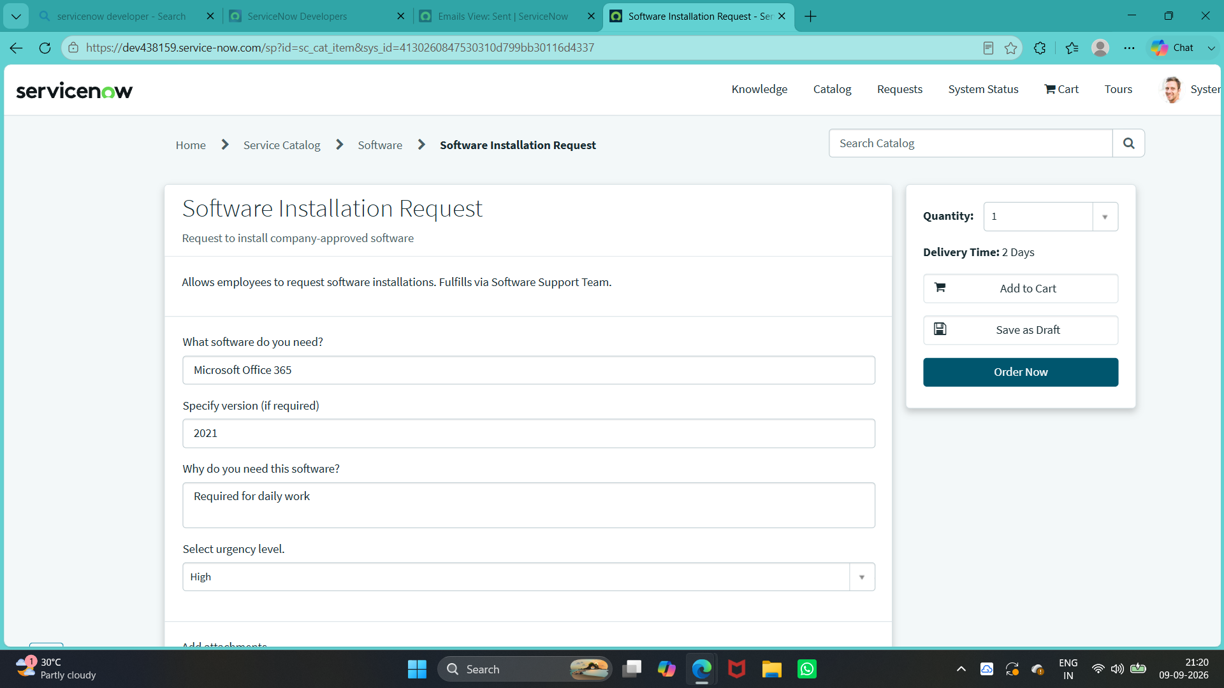
Figure 6: Example Software Installation Request with Submitted Variables

Phase 3 – Workflow Automation & Approval
The third phase focuses on improving the user interface and user experience of the Licensed Software Installation Request in ServiceNow. The objective is to make the catalog request form simple, clear, and easy for employees to complete while ensuring that the required information is captured correctly.
3.1 Form Layout and Field Organization
The Licensed Software Installation Request form is organized around the information required to process a software installation request.
Software Information
• Software Name
• Version Required
Business Information
- License Justification
Priority Information
- Urgency

This arrangement helps the requester provide information in a logical sequence.

3.2 Mandatory Field Validation
The catalog item captures the key information required for processing the software request:
Software Name,
Version Required,
License Justification,
Urgency.
This prevents incomplete requests from entering the workflow.

3.3 User-Friendly Field Configuration
Appropriate variable types are used according to the information being captured.
For example
Field | UI Purpose
Software Name | Enter the software required
Version Required | Enter the required software version
License Justification | Enter the business reason for the request
Urgency | Select the urgency level

3.4 Example of Customized Request Form
A completed request demonstrates how the customized UI captures the information required for processing.
Example values include:
• Software Name: Microsoft Office
• Version Required: Microsoft Office 2024
• License Justification: Required for academic and office-related work
• Urgency: Normal

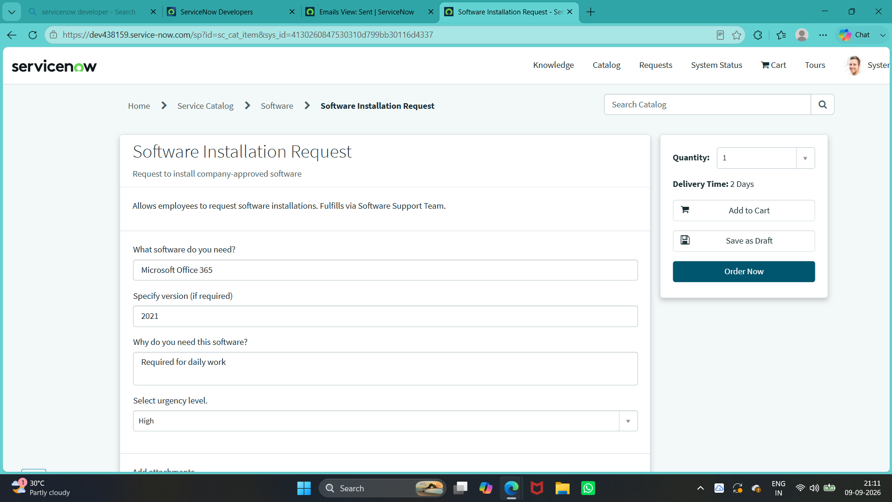
Figure 3.1: Software Installation Request – Configured Catalog Form

3.5 Workflow Integration
The customized form is designed to work with the subsequent automation process:
Catalog Item → Request (REQ) / Requested Item (RITM) → Approval → Catalog Task → Fulfillment
Therefore,focused on appearance but also ensures that the information collected from the employee can be consumed by the workflow.
· The Software Request Workflow is configured in Flow Designer.
· Approval processing is automated.
· Approved requests automatically create a Catalog Task.
· The task is assigned to the available Software support group.
· The request flow is traceable through REQ, RITM, and SCTASK records
3.6 Workflow Automation Overview
The workflow is designed to reduce manual processing and ensure that every software request follows a controlled process.
Employee → Catalog Request → REQ/RITM → Approval → Catalog Task → Fulfillment → Status Tracking
The workflow is implemented using the ServiceNow workflow/Flow Designer environment.
3.7 Workflow Configuration
The configured workflow is:
Software Request Workflow
The configured flow is Software Request Workflow. It is triggered when a Catalog Item is requested and processes the Requested Item through approval and fulfillment task creation.
The flow contains:
- Catalog Item Requested
- Ask For Approval on Requested Item
- If Approval Approved
- Create Catalog Task
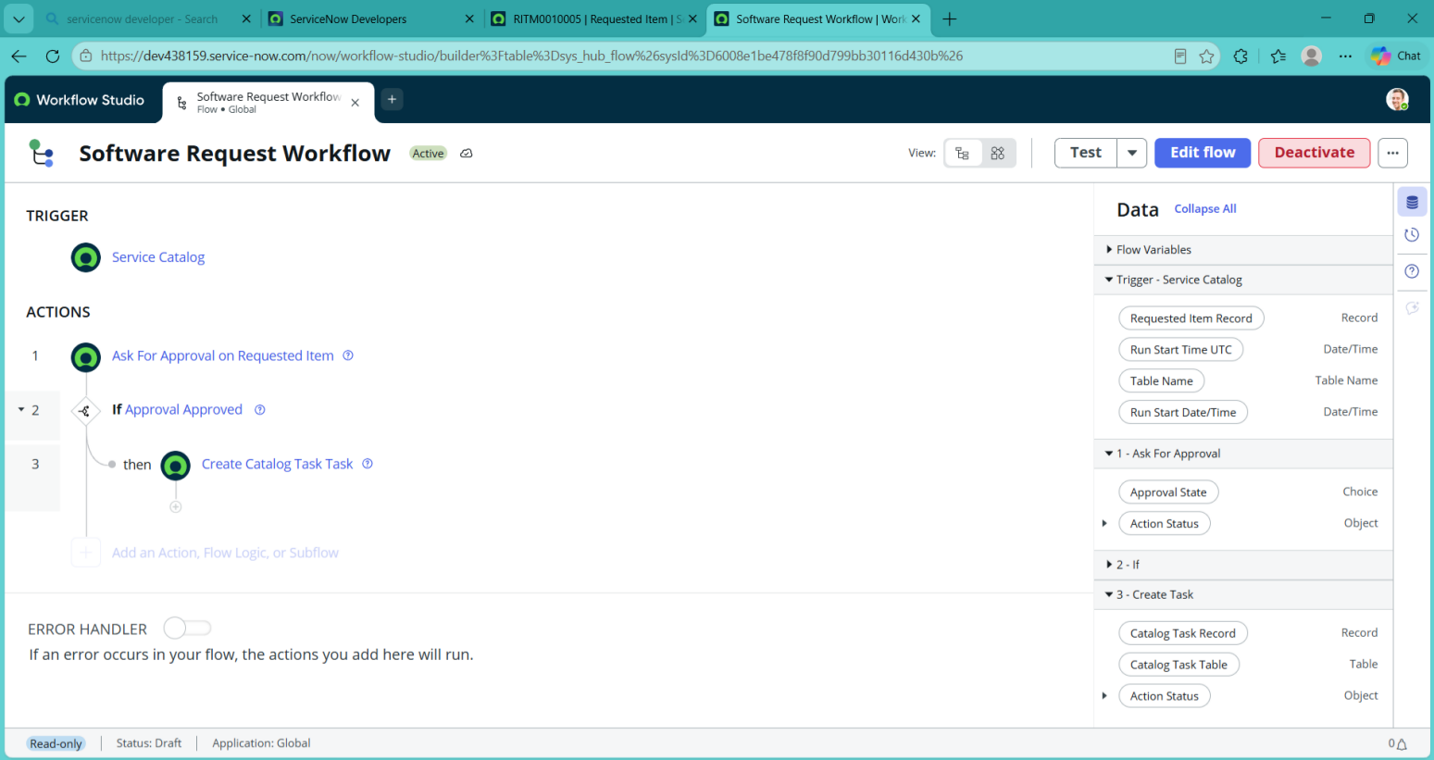
Figure 4: Software Request Workflow – Approval and Catalog Task Creation

3.8 Approval Process
After the request is submitted, the flow sends the Requested Item for approval using the Ask For Approval action. The configured approver reviews the request and provides the approval decision.
- Requested software
- Business justification
- Employee
- Department
- Device
- Required date
- Urgency
- License information
The approval decision determines whether the request can proceed.
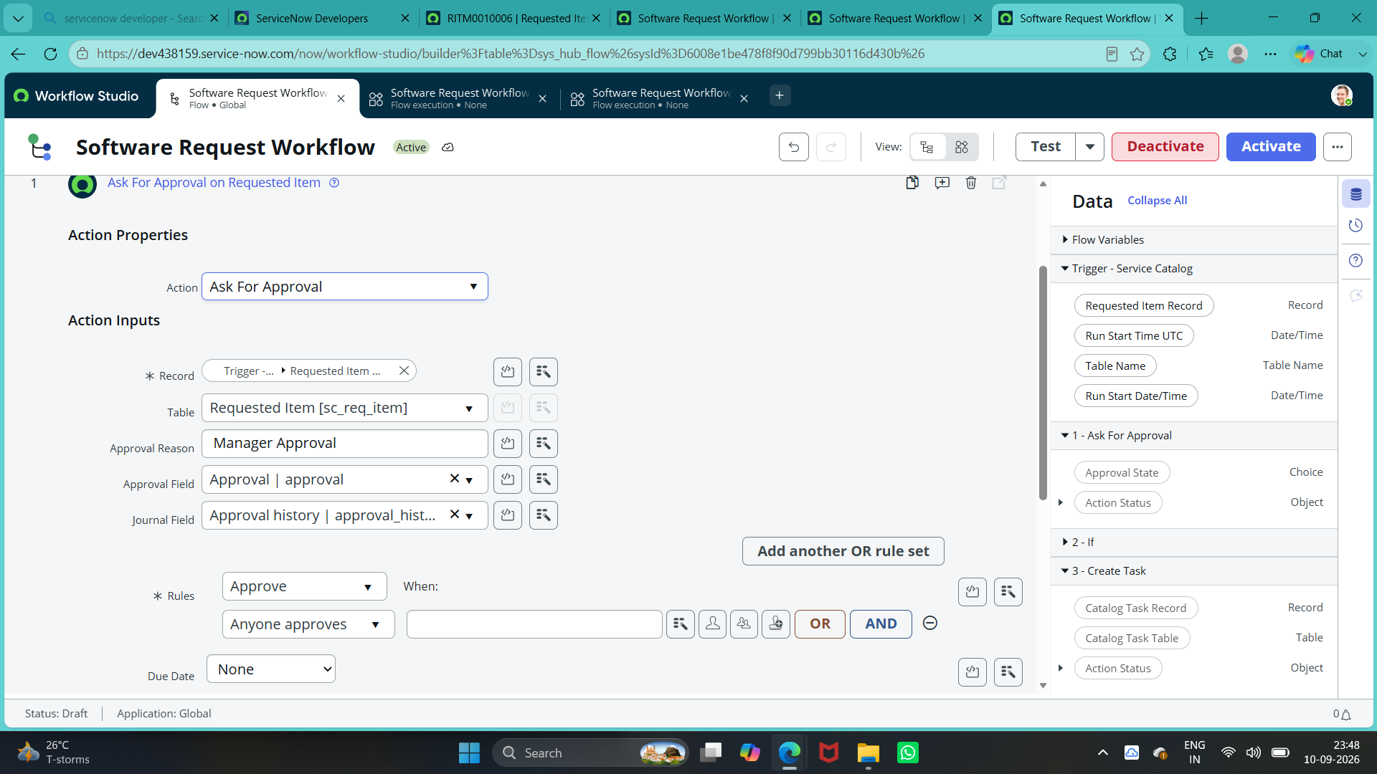
Figure 5: Software Request Workflow – Ask For Approval Configuration

3.9 Approval Decision
The flow evaluates whether the approval result is Approved.
If Approved: the flow continues to Create Catalog Task.
The request does not proceed to the task-creation step until the approval condition is satisfied.
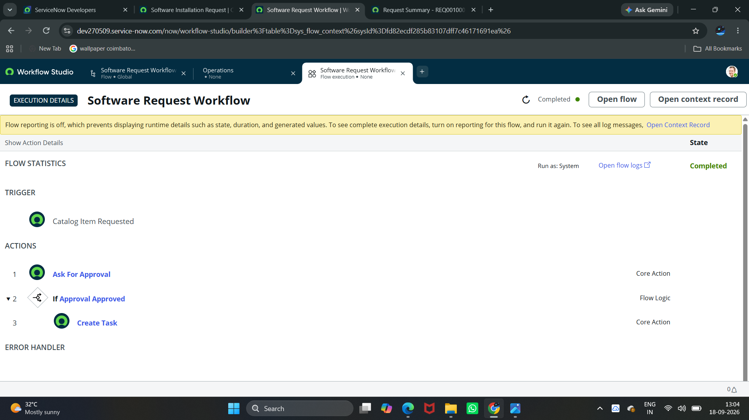
Figure 6: Software Request Workflow – Execution Detail
3.10 Catalog Task Creation
Once the request passes the required approval and license checks, the workflow creates a Catalog Task (sc_task) for the software support team.
The task contains the information required to perform the installation.
The task is assigned to:
Software support group
The support team can then process the installation and update the task status.
Once the request is approved, the flow automatically creates a Catalog Task (sc_task) with the short description Software Fulfillment Task. The task is assigned to the available Software support group for fulfillment.
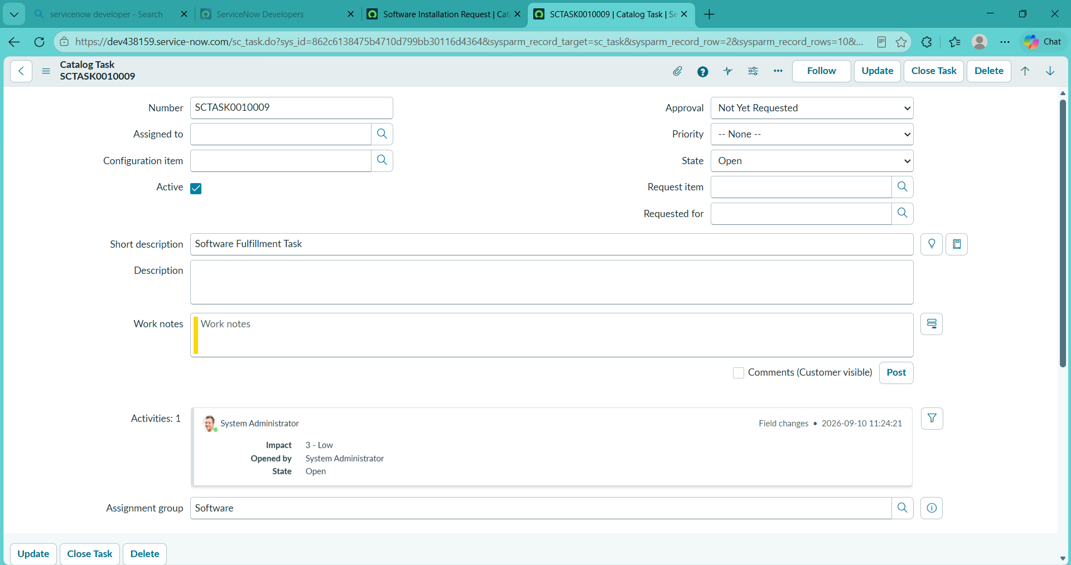
Figure 7: Software Fulfillment Catalog Task – SCTASK0010009

3.11 Fulfillment Process
The fulfillment process follows:
Approved Request → Catalog Task → Software Support Group → Task Processing → Task Status Update
The support team installs the requested software on the specified device and updates the catalog task.
Once fulfillment is completed, the request can move toward closure.

3.12 Notifications
ServiceNow email records generated during request processing were reviewed as part of testing to verify request and approval-related communication.

3.13 Update Set
The workflow automation configuration is captured in the update set:
Licensed Software Installation - Capstone
This allows the workflow-related configuration to be tracked and moved between ServiceNow instances as required.
The project configuration was captured in the Licensed Software Installation - Capstone Update Set. The Update Set was completed, exported, imported into a target instance, previewed, and committed successfully.
3.14 End-to-End Workflow
The complete automated process is:
Employee
↓
Software Installation Request
↓
REQ / RITM
↓
Ask For Approval
↓
Approval Decision
↓
Create Catalog Task
↓
Software Support Group
↓
Task Processing / Status Update

3.15 Phase 3 Outcome
At the end of Phase 3:
· The Software Request Workflow is automated.
· Approval processing is configured using Flow Designer.
· Approval decisions control the next step of the flow.
· Catalog Tasks are automatically created after approval.
· The generated task uses the Software support group for fulfillment.
· Request and task records remain traceable through REQ, RITM, and SCTASK.

Phase 4 – Testing & Validation
The fourth phase focuses on validating the Software Installation Request to ensure that the catalog item, request generation, approval flow, and Catalog Task creation work correctly. Testing was performed by submitting a software request and reviewing the resulting flow execution and fulfillment task.
4.1 Testing Objectives
The main objectives of this phase are:
- Verify that the catalog request form works correctly.
- Verify REQ and RITM creation.
- Verify approval routing and approval decisions.
- Confirm automatic Catalog Task creation.
- Verify assignment to the Software Support Team.
- Verify all configured notifications.
- Confirm request status updates and closure.
- Ensure appropriate access and security controls are applied.

4.2 Functional Testing
Functional testing verifies that each major function of the software request process operates according to the requirements.
Test Area | Expected Result
Catalog item access | Employee can access Software Installation Request
Request submission | Request is submitted successfully
REQ/RITM creation | REQ and RITM are generated
Approval | Request is sent for approval
Approval decision | Approved request continues in the flow
Catalog Task | Task is created after approval
Assignment | Task is assigned to the Software support group
Flow execution | Software Request Workflow completes successfully
Task tracking | Catalog Task can be viewed and its state updated

4.3 Catalog Form Testing
The catalog form is tested with valid and invalid inputs.
Valid Input Testing
A complete request is submitted with all required values, such as:
• Software Name: Microsoft Office
· Version Required: Microsoft Office 2024
· License Justification: Required for academic and office-related work
· Urgency: Normal
The system should successfully submit the request and create the corresponding RITM.

Invalid Input Testing
The form is also tested by:
- Leaving mandatory fields empty.
- Entering incomplete information.
- Selecting invalid or unsupported values.
- Attempting to submit without required request details.
The system should prevent incomplete requests from being submitted.
4.4 Workflow Testing
The complete workflow is tested from submission through fulfillment.
Employee Submission → REQ/RITM → Approval → Catalog Task Creation
Each workflow stage is verified to ensure that the request moves to the correct next step.

4.5 Approval Testing
The approval process was tested using the configured Ask For Approval action. After approval, the flow evaluated the approval condition and continued to Catalog Task creation.
Approval testing verifies both possible approval outcomes.
Approved Request
Request → Approval → Approved → Catalog Task → Software Installation
The approved request should continue toward fulfillment.
Rejected Request
Request → Approval → Rejected → Requester Notification
A rejected request should not proceed to software installation.
4.6 Catalog Task Testing
After the approval was completed, the flow automatically created a Catalog Task for software fulfillment. The generated task was verified in the sc_task table
The notification configuration and delivery are verified to ensure that the correct recipient receives the appropriate message at the correct stage.

Figure: Software Fulfillment Catalog Task – SCTASK0010009

4.7 Email Validation
ServiceNow email records generated during request processing were reviewed to verify request and approval-related communication.
4.8 End-to-End Testing
The complete scenario is tested using a real software installation request.
Employee submits request
↓
REQ/RITM created
↓
License availability checked
↓
Manager approval requested
↓
Approval decision recorded
↓
Catalog Task created
↓
Software Support group
↓
Task processing
Successful completion of this scenario confirms that the major components work together correctly.
4.9 Testing Results
The testing phase confirmed that:
· The Software Installation Request catalog item is available.
· REQ/RITM records are generated.
· Approval processing executes through Flow Designer.
· The approval condition controls the next workflow step.
· A Catalog Task is automatically created after approval.
· The generated task is assigned to the Software support group.
· The Software Request Workflow executes successfully in the target instance.

Phase 5 – Deployment, Documentation & Final Presentation
The fifth and final phase focuses on preparing the Licensed Software Installation Request application for deployment, documenting the completed implementation, and presenting the final solution. This phase ensures that the configured ServiceNow components are properly packaged, validated, and ready for demonstration or transfer to another environment.

5.1 Deployment Preparation
Before deployment, the completed configuration is reviewed to ensure that all required Before deployment, the completed configuration was reviewed to ensure that the required components were included.
· Service Catalog Item
· Catalog Variables
· Flow Designer configuration
· Approval configuration
· Catalog Task configuration
· Update Set
· Related request configuration

5.2 Update Set Configuration
The project configuration is captured using the ServiceNow Update Set:
Licensed Software Installation - Capstone
The update set provides a controlled method for tracking configuration changes and moving the developed solution between ServiceNow instances.
The project configuration was captured in the Licensed Software Installation - Capstone Update Set. The completed Update Set was used to transfer the project configuration from the source instance to the target instance.
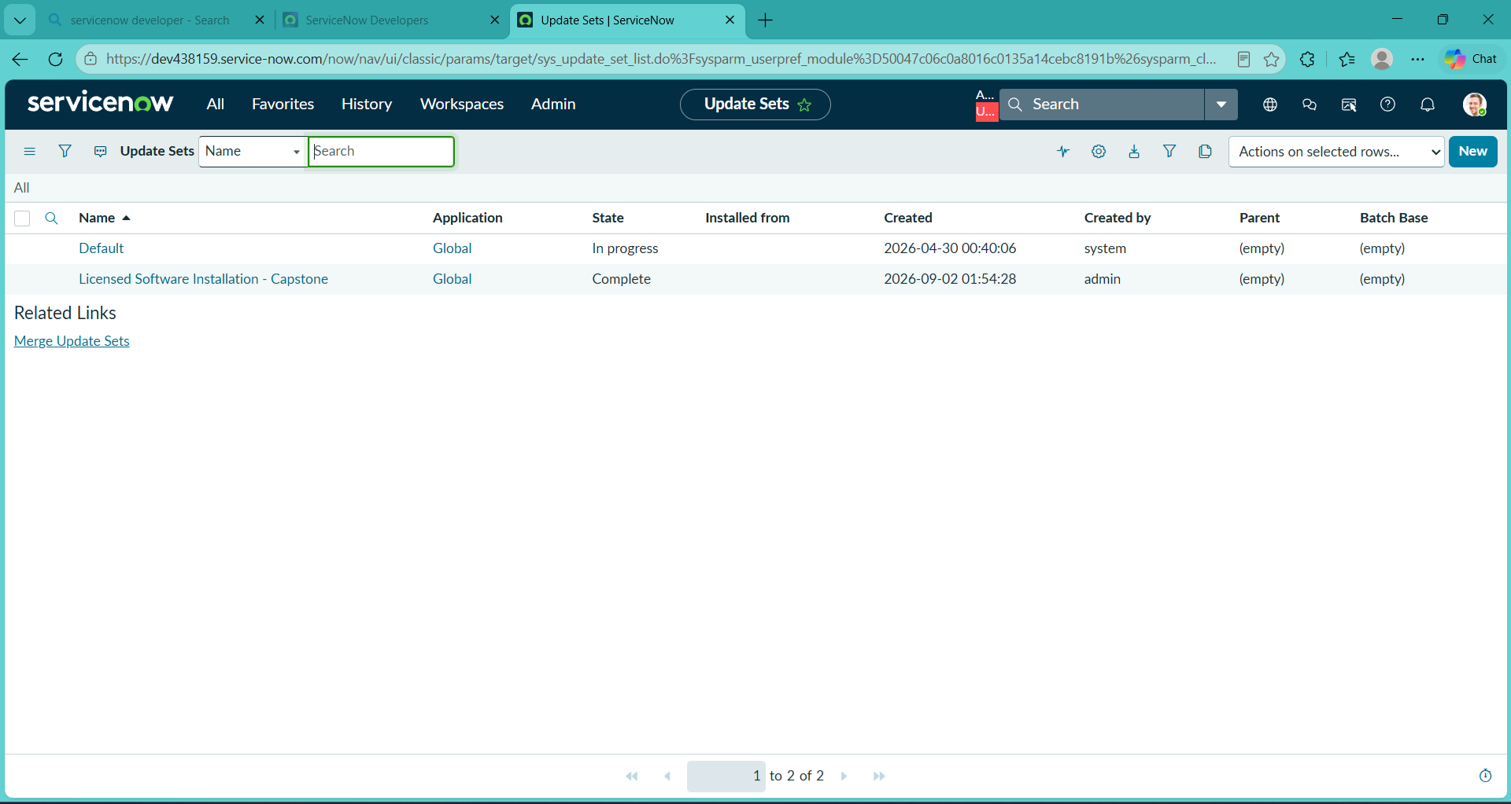
Figure 5.1: Licensed Software Installation - Capstone – Completed Update Set

5.3 Update Set Deployment
The completed Update Set was exported from the source instance and imported into the target instance. The imported Update Set was previewed, the preview problems were resolved, and the Update Set was successfully committed.
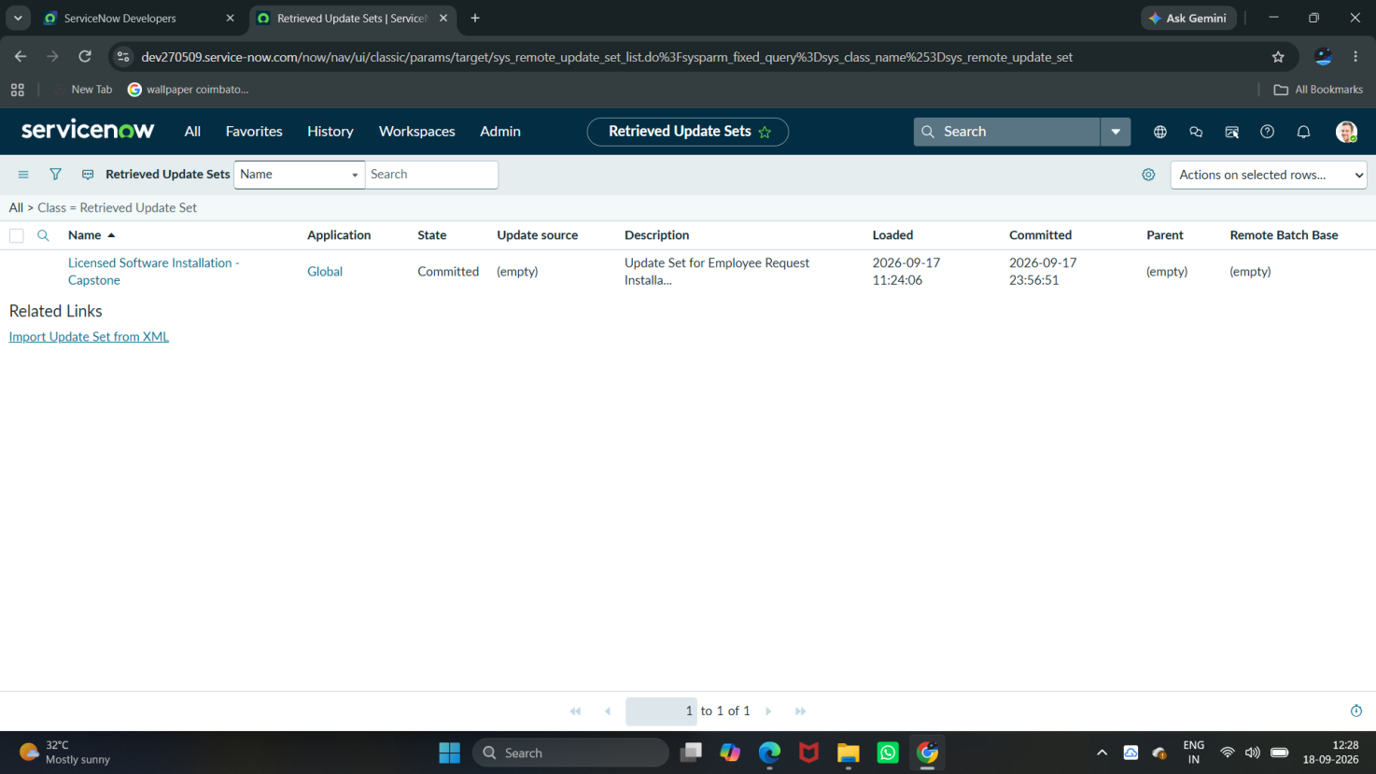
Figure 5.2: Licensed Software Installation - Capstone – Committed Update Set
5.4 Post-Deployment Validation
After deployment, the transferred configuration was validated in the target instance. The Software Installation Request catalog item and Software Request Workflow were verified,
The deployment process includes:
Development → Testing → Update Set Completion → Export/Retrieve → Target Instance → Validation
The retrieved update set is reviewed before committing the changes to the target environment.
Figure 5.3: Software Installation Request – Target Instance Validation
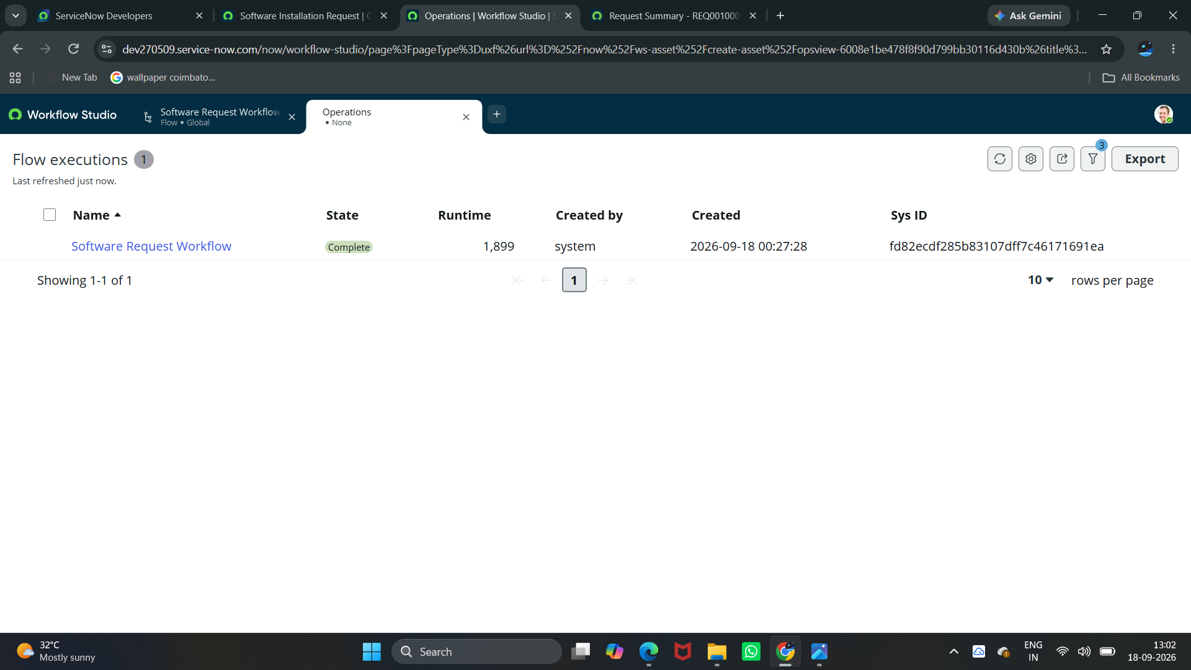
Figure 5.4: Software Request Workflow – Successful Target-Instance Execution

5.5 Documentation
The project documentation records the complete implementation process, including:
Phase 1 – Requirement Analysis & Planning
Requirement identification, stakeholders, functional requirements, and project planning.
Phase 2 – Service Catalog & Form Configuration
Catalog item, variables, form configuration, validation, and REQ/RITM generation.
Phase 3 – Workflow Automation & Approval
Form layout, mandatory fields, and user experience improvements.Workflow, license validation, approval process, catalog task creation, notifications.
Phase 4 – Testing & Validation
Functional testing, workflow testing, approval testing, notification testing, SLA testing, security testing, and end-to-end validation.
Phase 5 – Deployment, Documentation & Final Presentation
Update Set, deployment, dashboard, final validation, documentation, and project presentation.
5.6 Final Demonstration Flow
The final presentation demonstrates the complete employee software request lifecycle:
Employee
↓
Service Catalog
↓
Licensed Software Installation Request
↓
REQ / RITM Creation
↓
Approval
↓
Catalog Task
↓
Software Support Group
↓
Task Processing
↓
Status Tracking

5.6 Final Project Deliverables
The completed project provides:
· Software Installation Request Catalog Item
· Configured Catalog Variables
· Software Request Workflow
· Approval Configuration
· Automated Catalog Task Creation
· Software Support Group Assignment
· Request and Task Tracking
· Update Set Deployment
· Target-Instance Validation
· Project Documentation and Demonstration
5.8 Phase 5 Outcome
At the end of Phase 5, the Software Installation Request solution was documented, tested, packaged using the Licensed Software Installation - Capstone Update Set, transferred to a target ServiceNow instance, committed successfully, and validated through a successful flow execution.
Final Workflow – Image Evidence Set
The following screenshots provide visual evidence for the complete process, from catalog request and workflow automation through approval, fulfillment, SLA monitoring, dashboard reporting, and deployment.

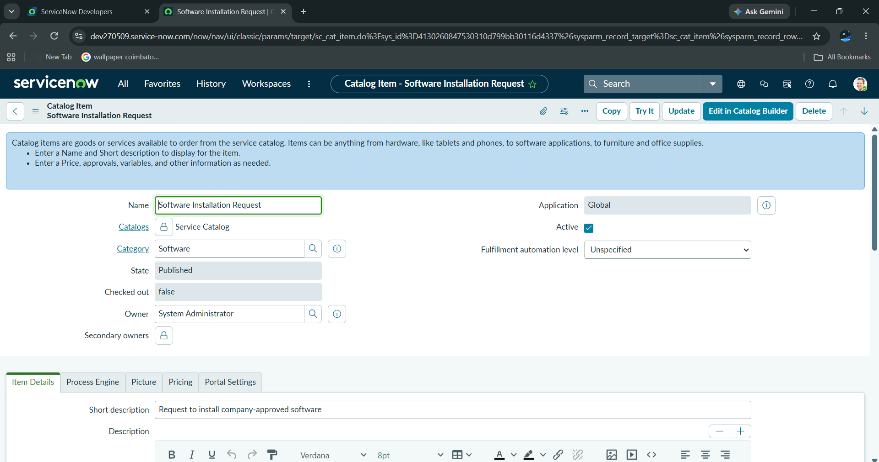

Figure 1:Licensed Software Installation Request – Catalog Item Configuration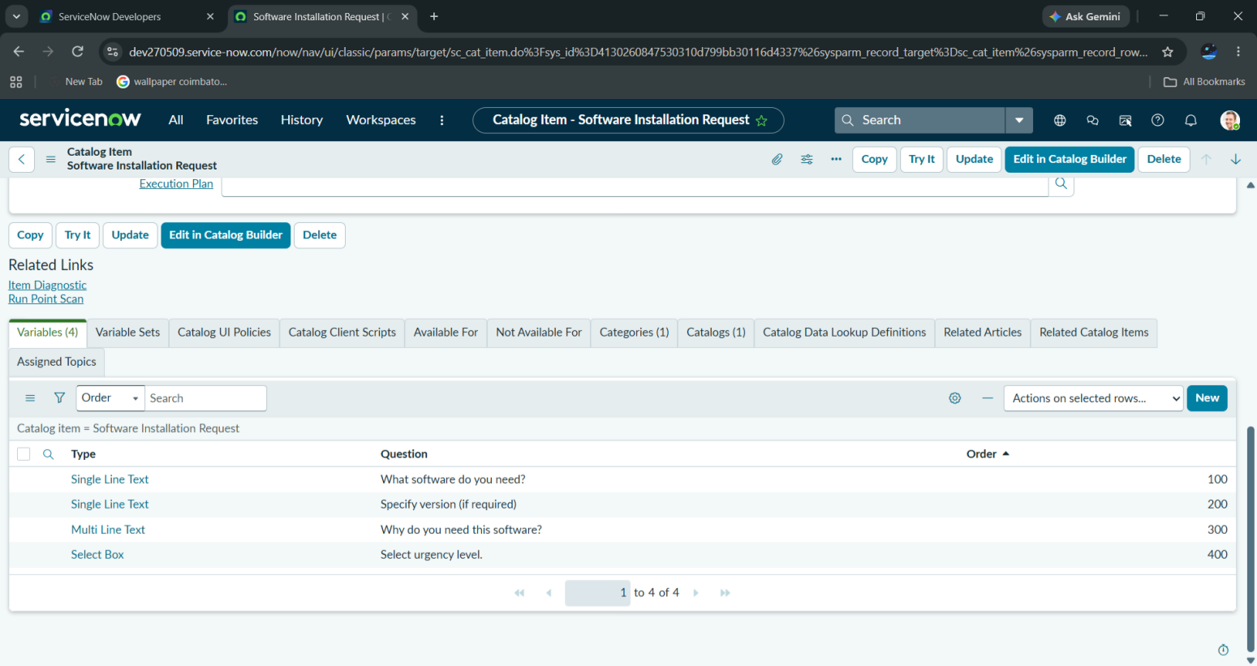
Figure 2: Licensed Software Installation Request – Configured Catalog Variables
Figure 3: Licensed Software Installation Request – Service Portal Request Form
Figure 4: Licensed Software Installation Request –filled Service Portal Request Form
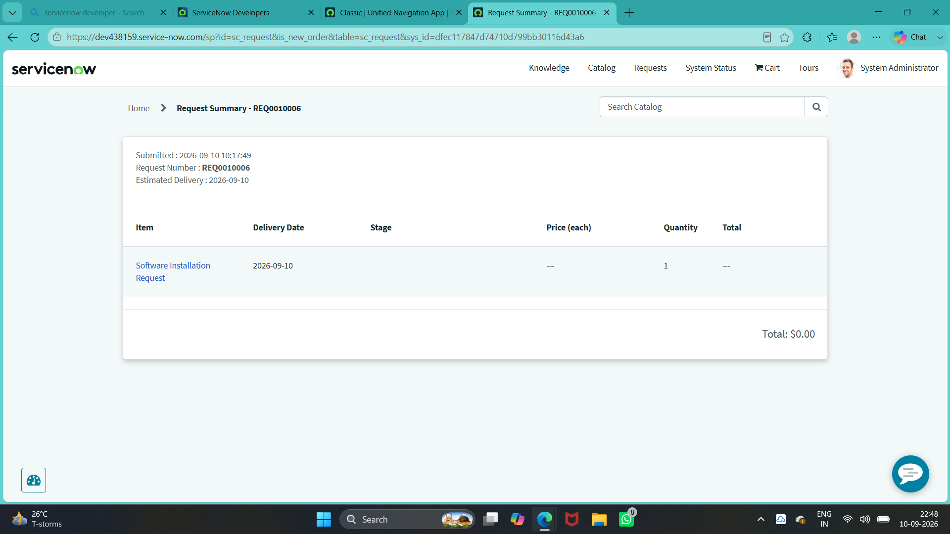
Figure 5: Licensed Software Installation Request – Generated REQ/RITM Record
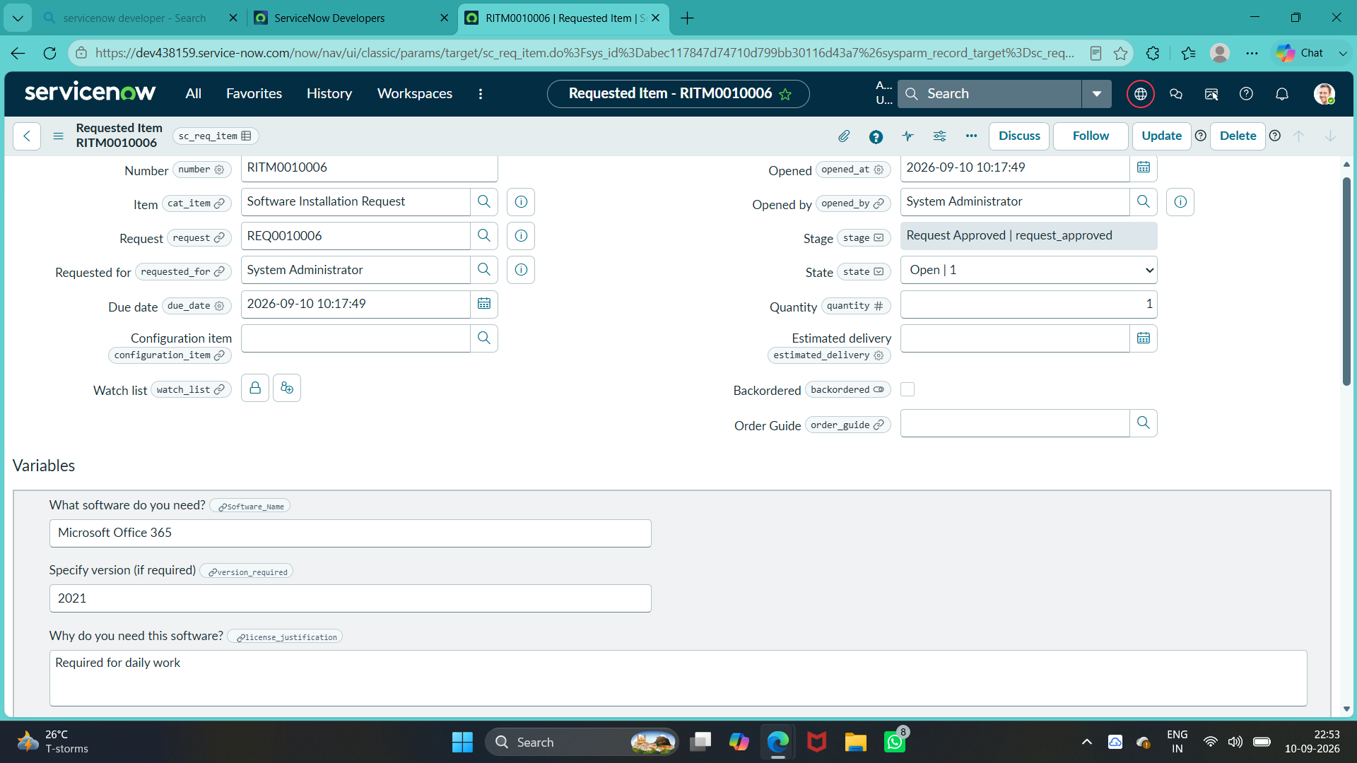
Figure 6: Licensed Software Installation Request – Generated REQ/RITM Record
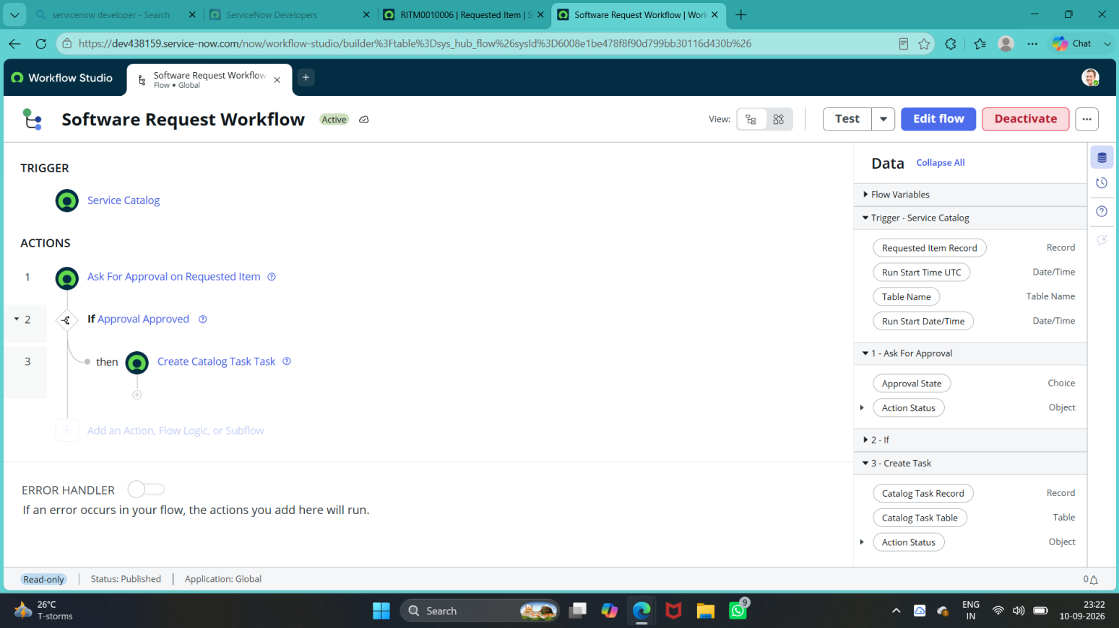
Figure 7: Software Request Workflow – Workflow Automation Configuration
Figure 8: Software Request Workflow – Approval Configuration
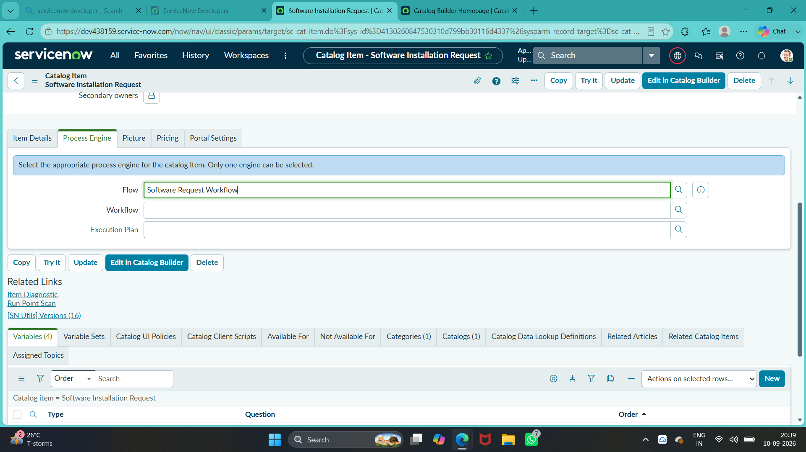
Figure 9: Software Installation Request – Process Engine Configuration
Figure 10: Software Request Workflow – Successful Flow Execution
Figure 11: Software Fulfillment Task – Catalog Task Configuration
Figure 12: Licensed Software Installation – Update Set Completed
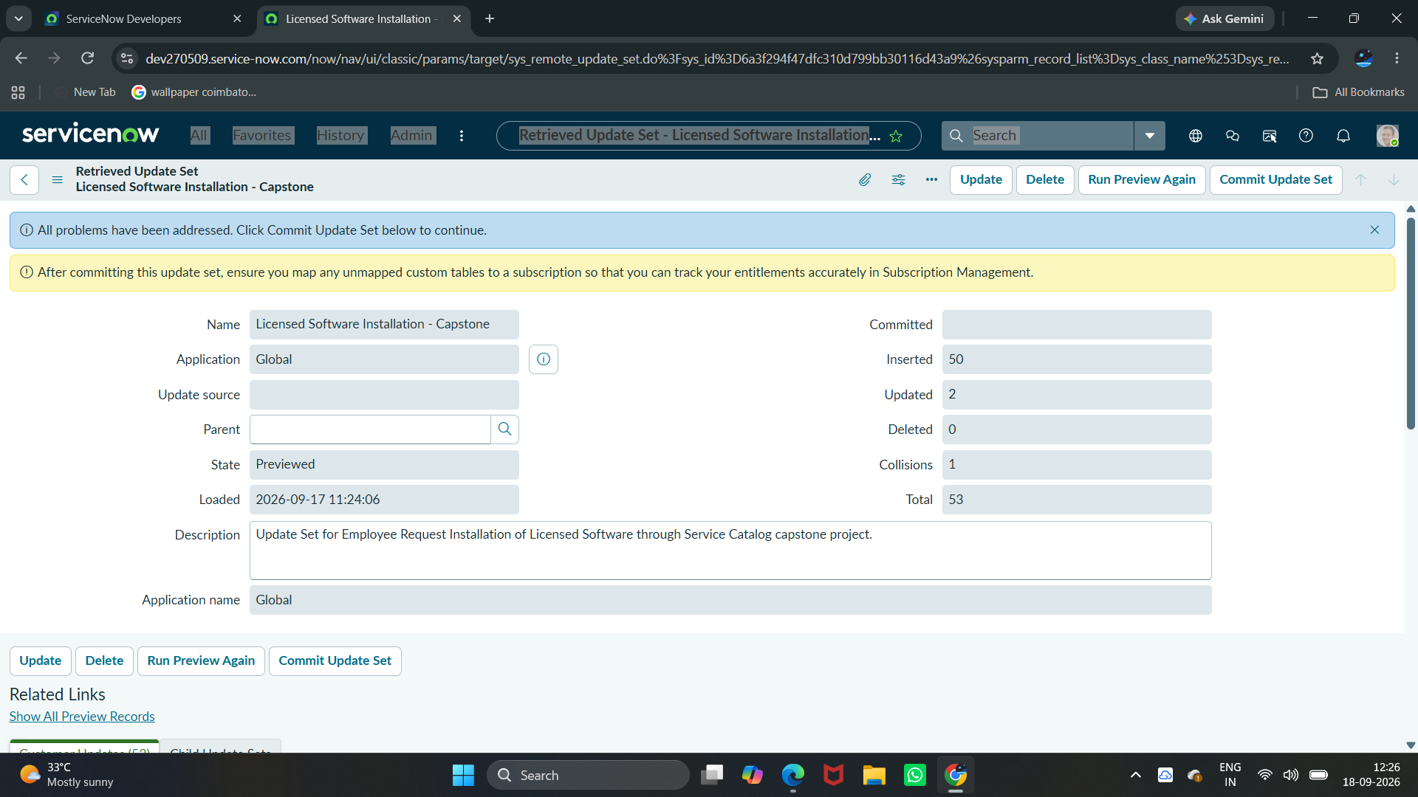
Figure 13: Licensed Software Installation – Update Set Preview Resolved
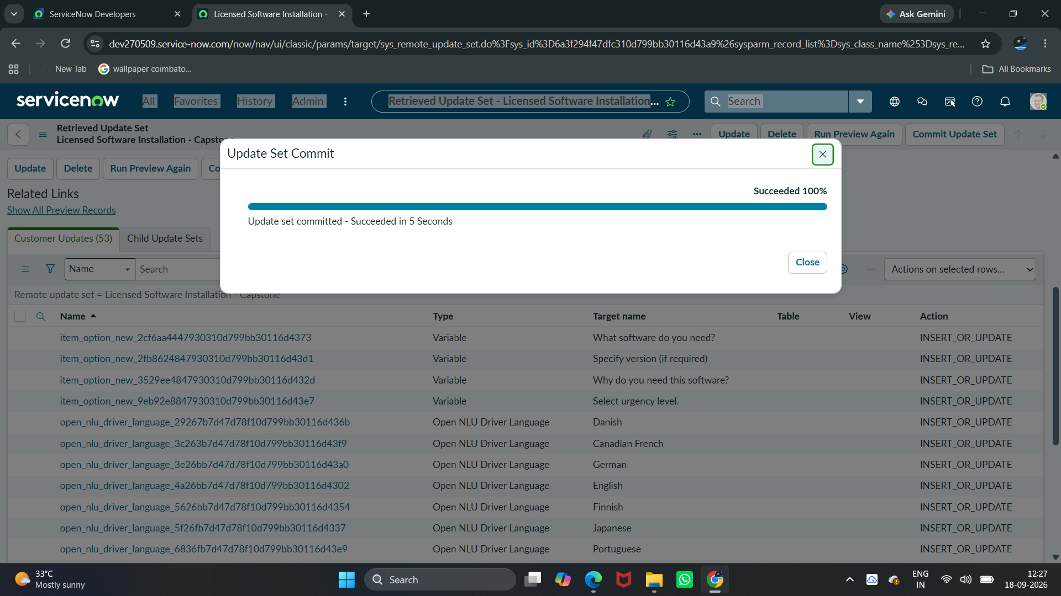
Figure 14: Licensed Software Installation – Update Set Committed
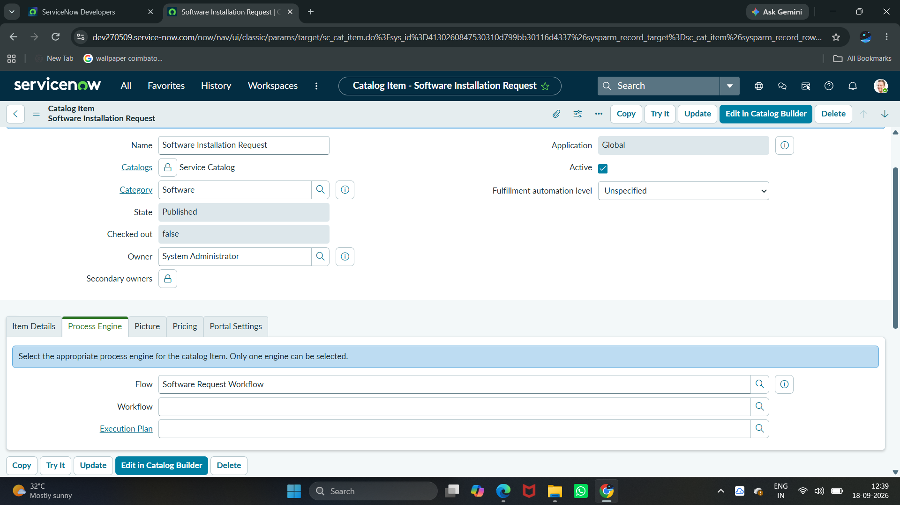
Figure 15: Target Instance – Software Installation Request Catalog Item

Figure 16: Target Instance – Software Request Workflow Execution

Project Conclusion
The Automated Licensed Software Installation Request Management project provides a structured ServiceNow-based process for managing employee software installation requests. Employees can submit a Software Installation Request through the Service Catalog by providing software name, required version, license justification, and urgency.
The request is processed through Flow Designer for approval, and after approval, a Catalog Task is automatically created for the Software support group. The solution provides traceability across REQ, RITM, and SCTASK records and uses Update Sets to transfer the completed configuration between ServiceNow instances.
Overall, the project demonstrates how ServiceNow can automate software request approval and fulfillment while improving request tracking and reducing manual coordination.
Final Project Flow
Employee Request → Service Catalog → REQ/RITM → Approval → Catalog Task → Software Support Group → Task Processing → Status Tracking

